Week 8: Jenkins Automation
- Hands-on practice on manual creation of Jenkins pipeline using Maven projects from Github
- Create the job and build the pipeline for maven-java and maven-web project.
- Questions on Jenkins
- Upload the Screenshots.

- Steps for MavenJava Automation:
Maven Java Automation Steps:
Step 1: Open Jenkins (localhost:8080)
├── Click on "New Item" (left side menu
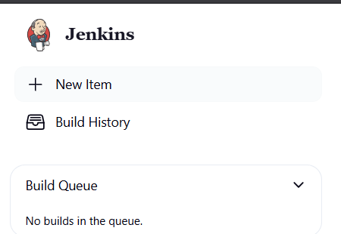
Step 2: Create Freestyle Project (e.g., MavenJava_Build)
├── Enter project name (e.g., MavenJava_Build)
├── Click "OK"
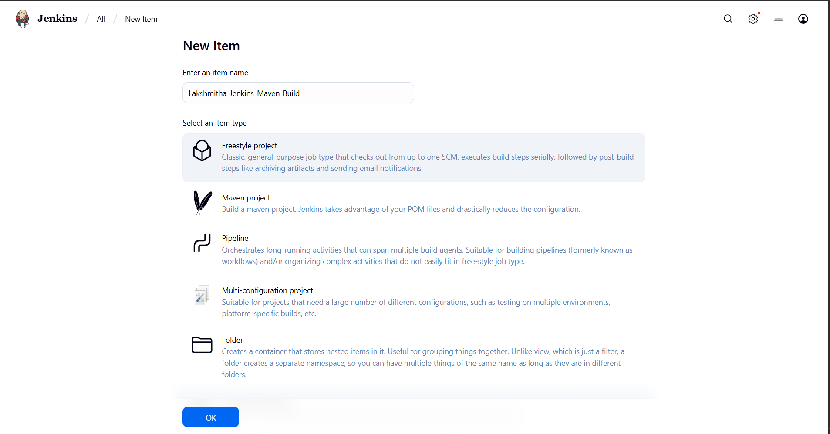
└── Configure the project:
├── Description: "Java Build demo"
├── Source Code Management:
└── Git repository URL: [GitMavenJava repo URL]
├── Branches to build: */Main or */master
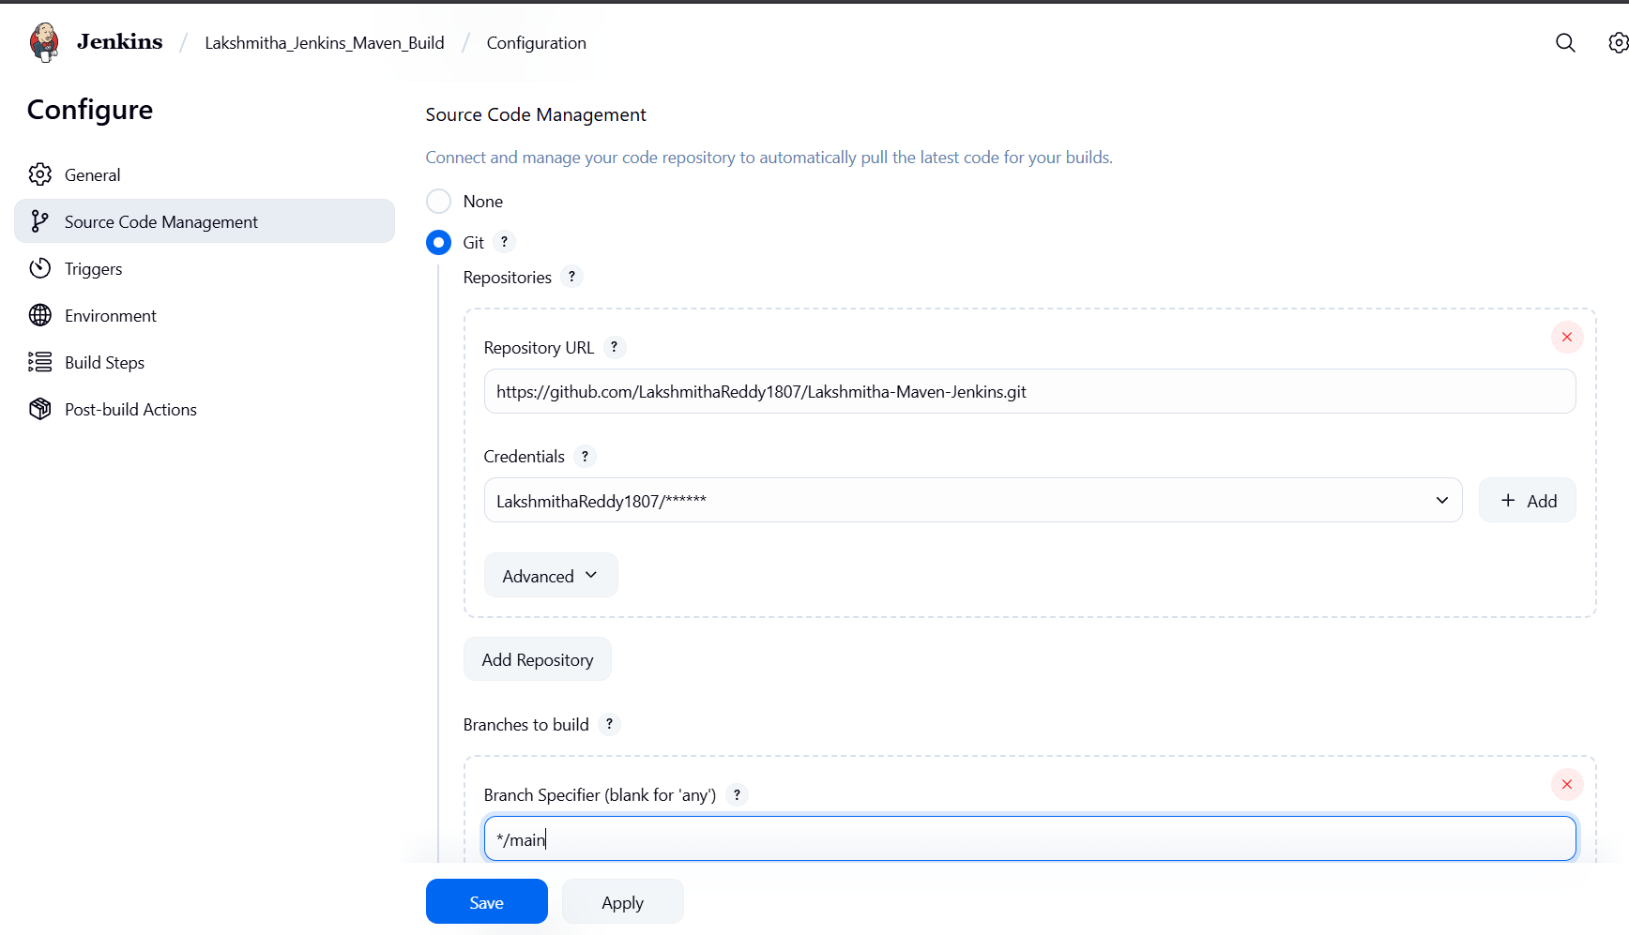
└── Build Steps:
├── Add Build Step -> "Invoke top-level Maven targets"
└── Maven version: MAVEN_HOME
└── Goals: clean
├── Add Build Step -> "Invoke top-level Maven targets"
└── Maven version: MAVEN_HOME
└── Goals: install
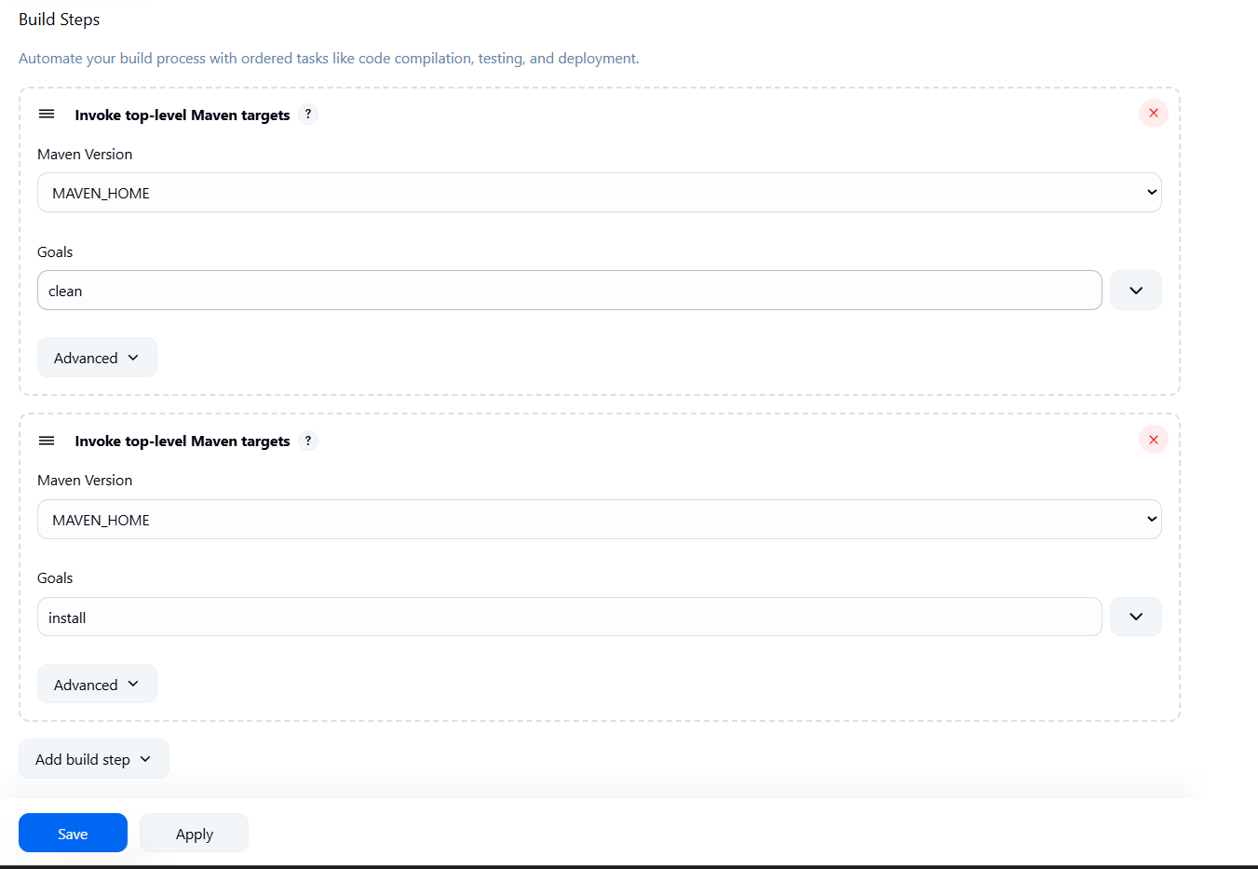
└── Post-build Actions:
├── Add Post Build Action -> "Archive the artifacts"
└── Files to archive: **/*
├── Add Post Build Action -> "Build other projects"
└── Projects to build: MavenJava_Test
└── Trigger: Only if build is stable
└── Apply and Save
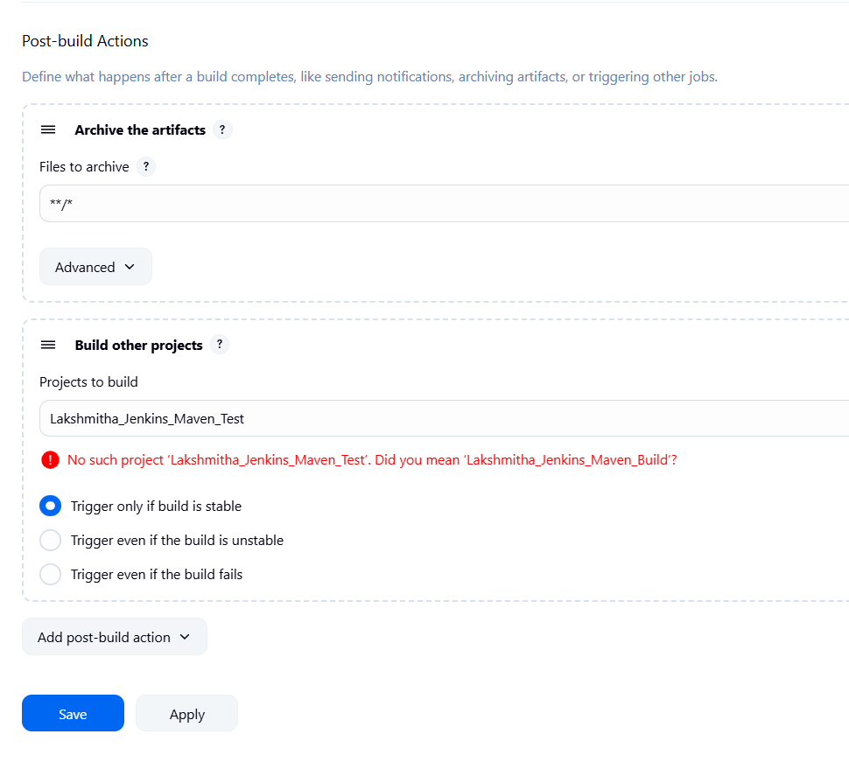

└── Step 3: Create Freestyle Project (e.g., MavenJava_Test)
├── Enter project name (e.g., MavenJava_Test)
├── Click "OK"
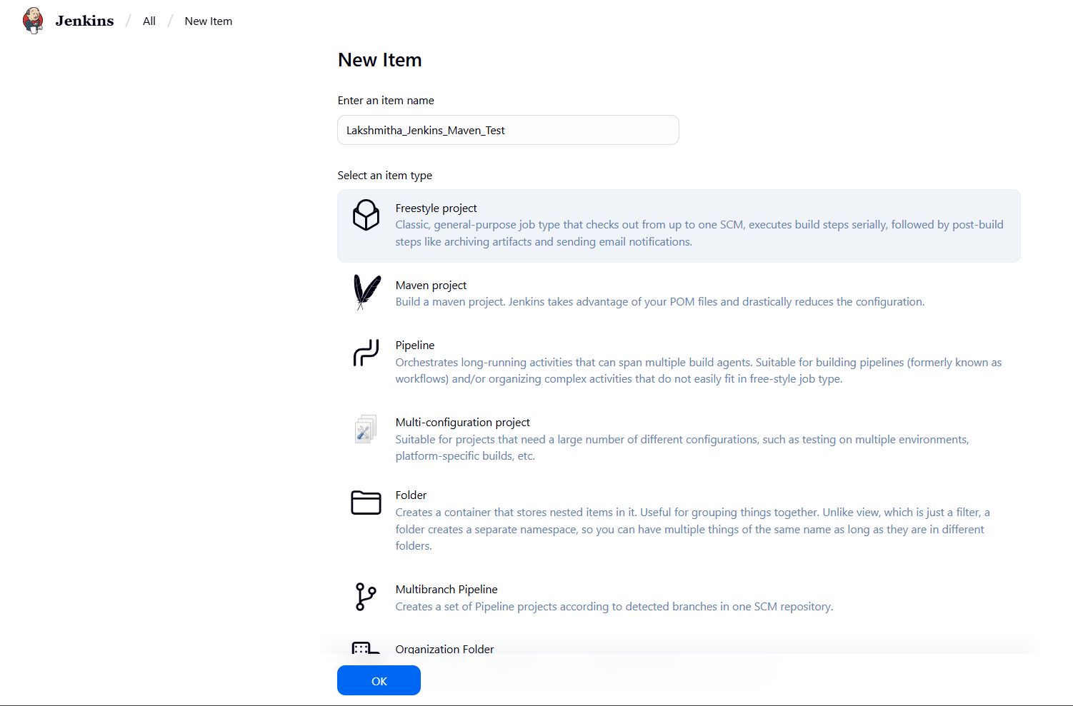
└── Configure the project:
├── Description: "Test demo"
├── Build Environment:
└── Check: "Delete the workspace before build starts"
├── Add Build Step -> "Copy artifacts from another project"
└── Project name: MavenJava_Build
└── Build: Stable build only // tick at this
└── Artifacts to copy: **/*
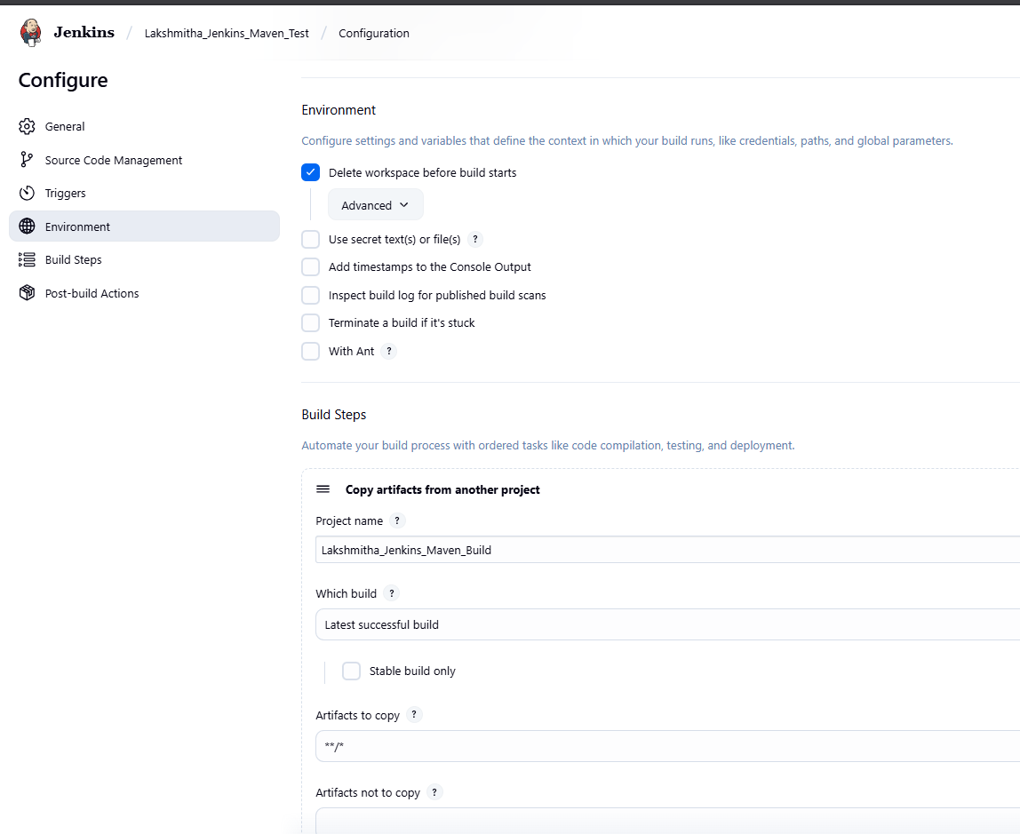
├── Add Build Step -> "Invoke top-level Maven targets"
└── Maven version: MAVEN_HOME
└── Goals: test
└── Post-build Actions:
├── Add Post Build Action -> "Archive the artifacts"
└── Files to archive: **/*
└── Apply and Save
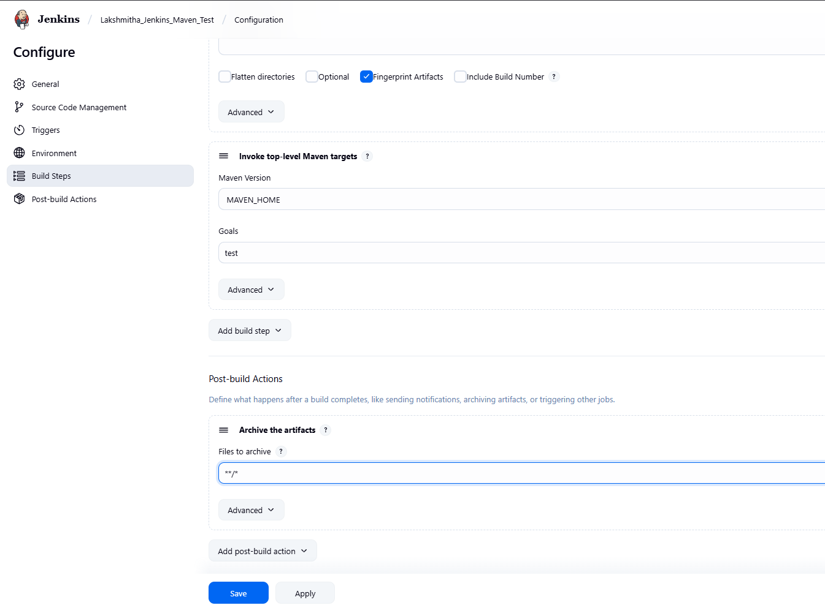
└── Step 4: Create Pipeline View for Maven Java project
├── Click "+" beside "All" on the dashboard
├── Enter name: MavenJava_Pipeline
├── Select "Build pipeline view" // tick here
|--- create
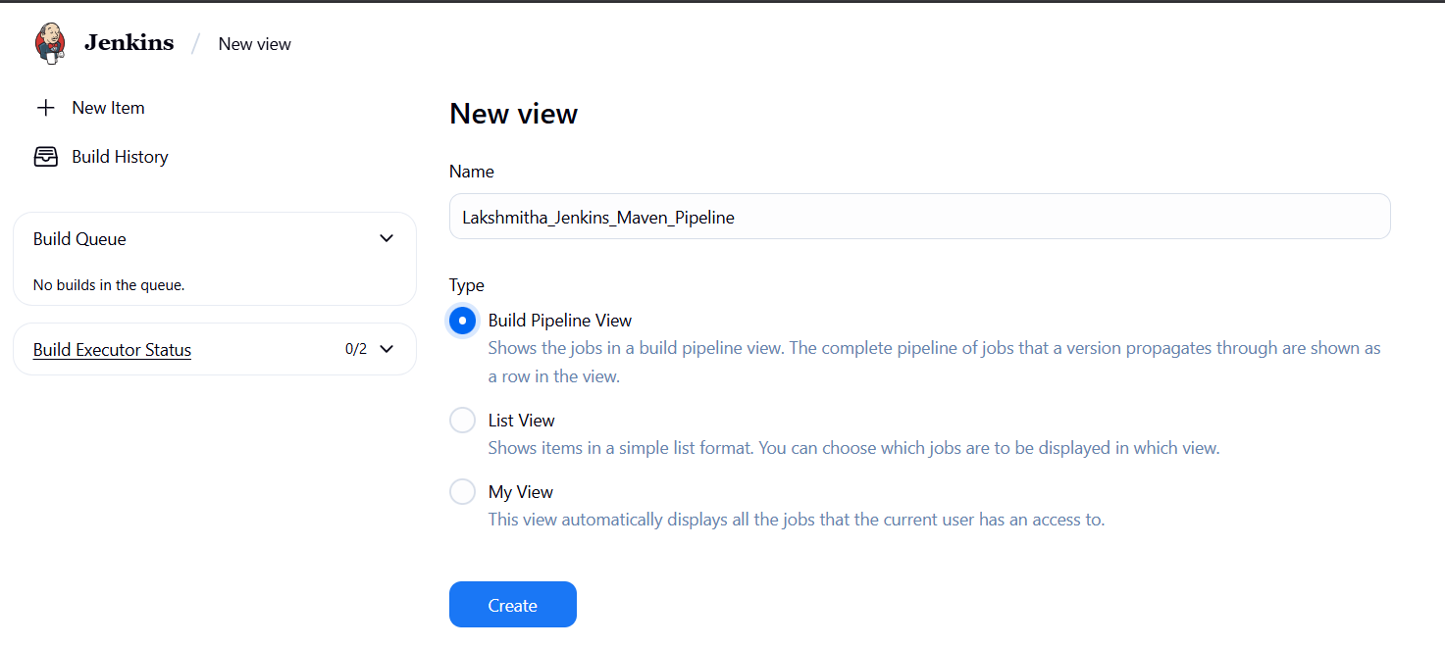
└── Pipeline Flow:
├── Layout: Based on upstream/downstream relationship
├── Initial job: MavenJava_Build
└── Apply and Save OK
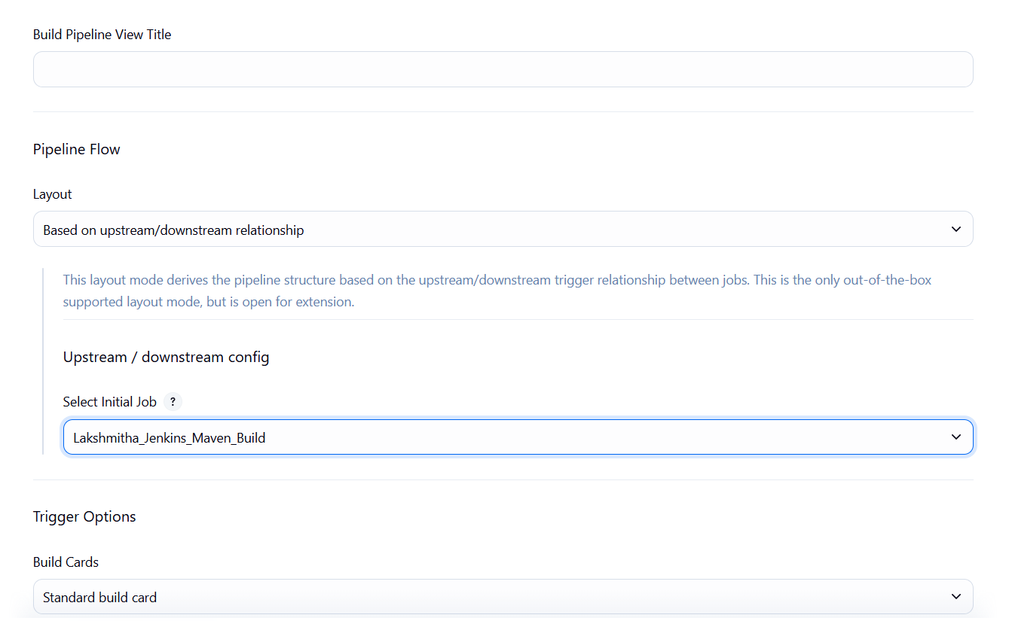
└── Step 5: Run the Pipeline and Check Output
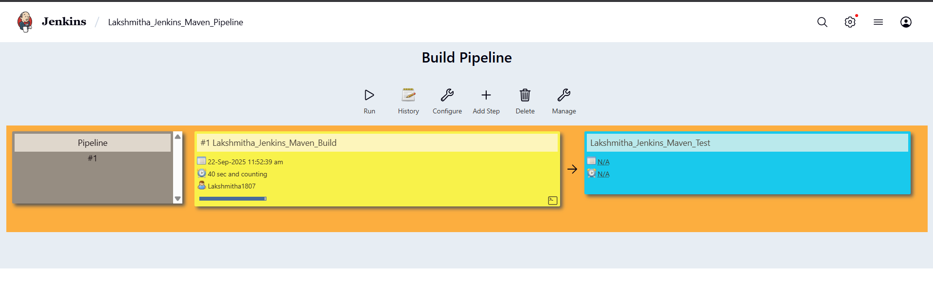
├── Click on the trigger to run the pipeline
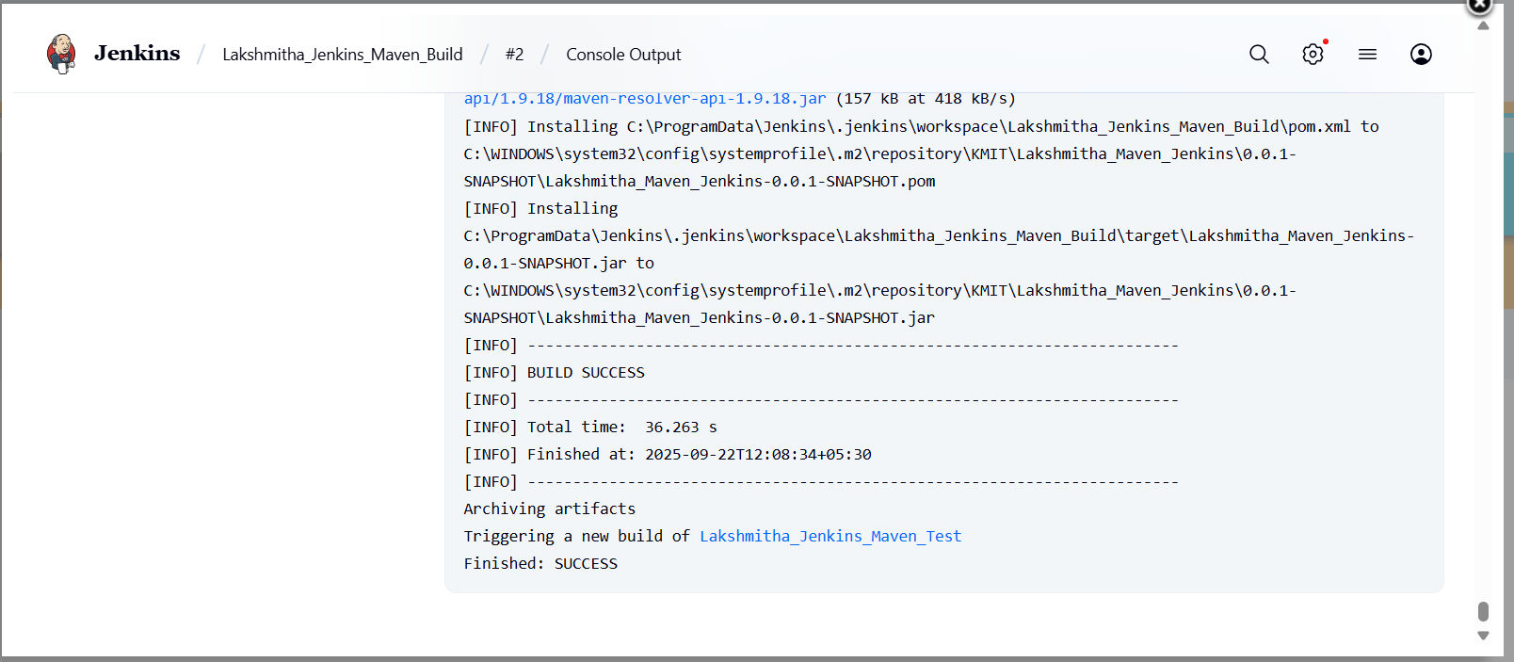
├── click on the small black box to open the console to check if the build is success
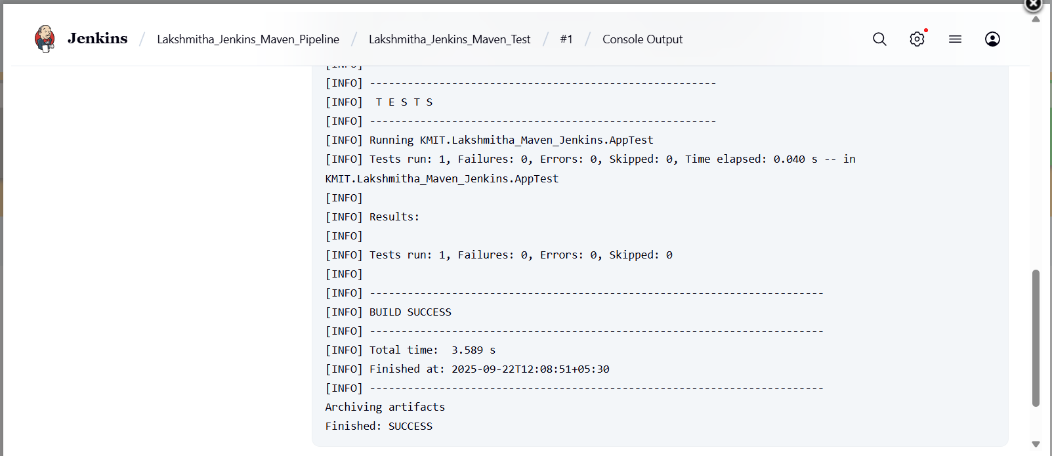
Note :
- If build is success and the test project is also automatically triggered with name
“MavenJava_Test”
- The pipeline is successful if it is in green color as shown ->check the console of the test project
- The test project is successful and all the artifacts are archived successfully
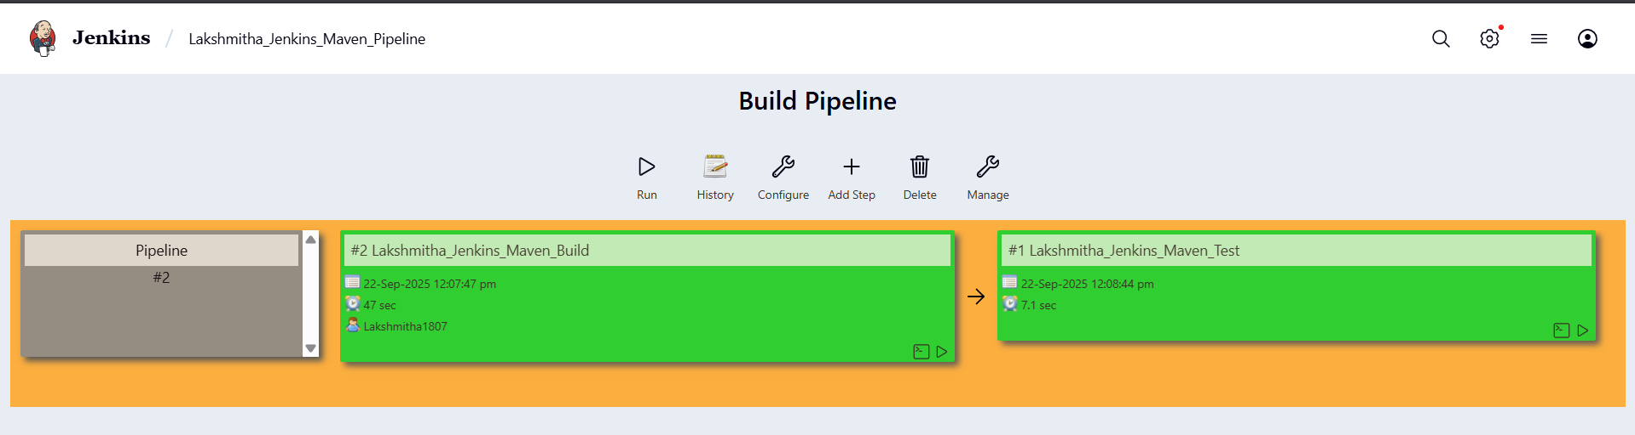
II. Maven Web Automation Steps:
└── Step 1: Open Jenkins (localhost:8080)
├── Click on "New Item" (left side menu)
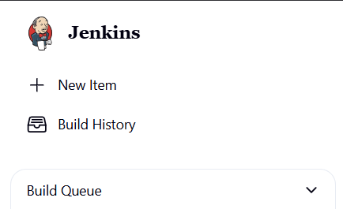
└── Step 2: Create Freestyle Project (e.g., MavenWeb_Build)
├── Enter project name (e.g., MavenWeb_Build)
├── Click "OK"
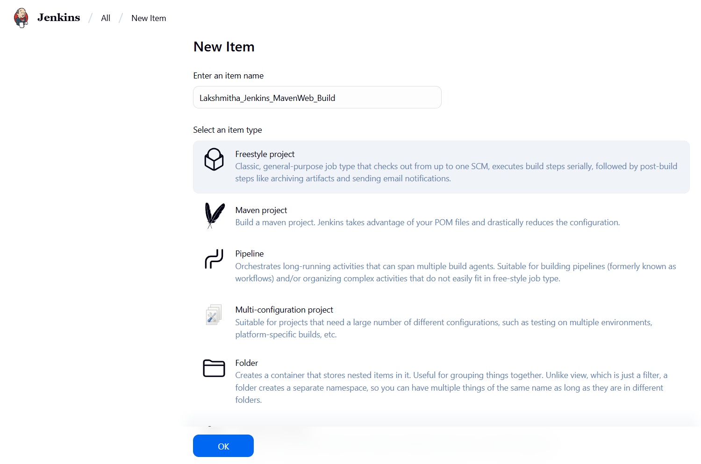
└── Configure the project:
├── Description: "Web Build demo"
├── Source Code Management:
└── Git repository URL: [GitMavenWeb repo URL]
├── Branches to build: */Main or master
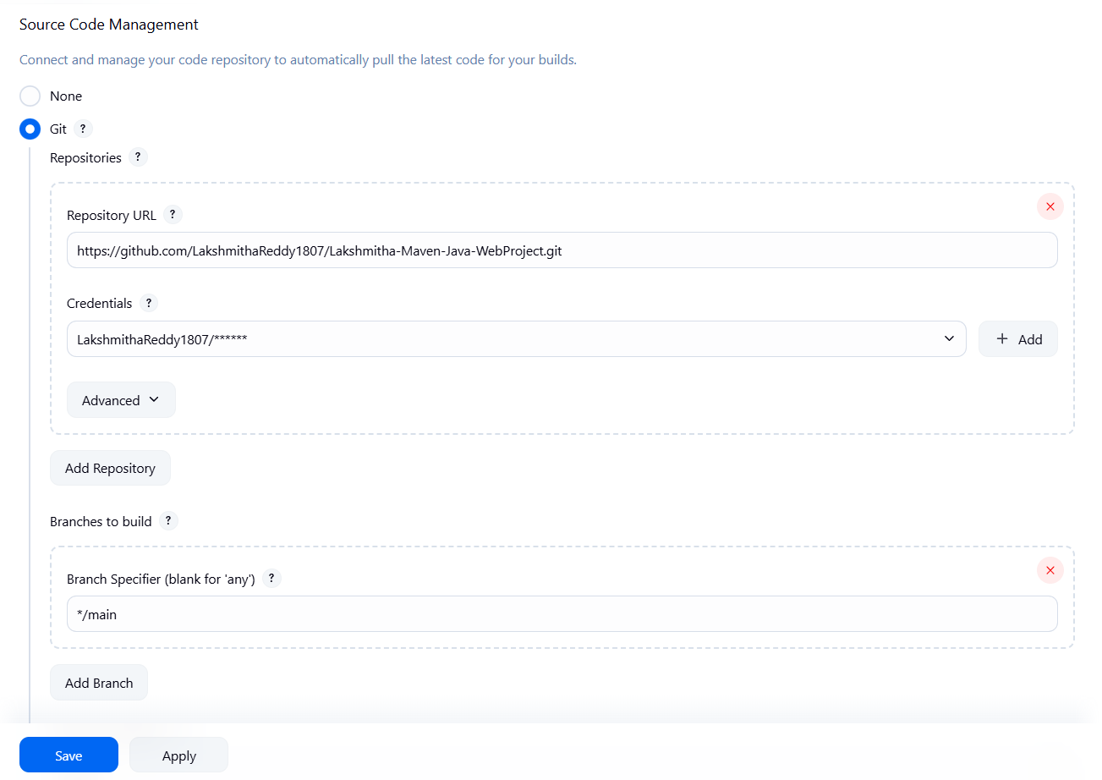
└── Build Steps:
├── Add Build Step -> "Invoke top-level Maven targets"
└── Maven version: MAVEN_HOME
└── Goals: clean
├── Add Build Step -> "Invoke top-level Maven targets"
└── Maven version: MAVEN_HOME
└── Goals: install
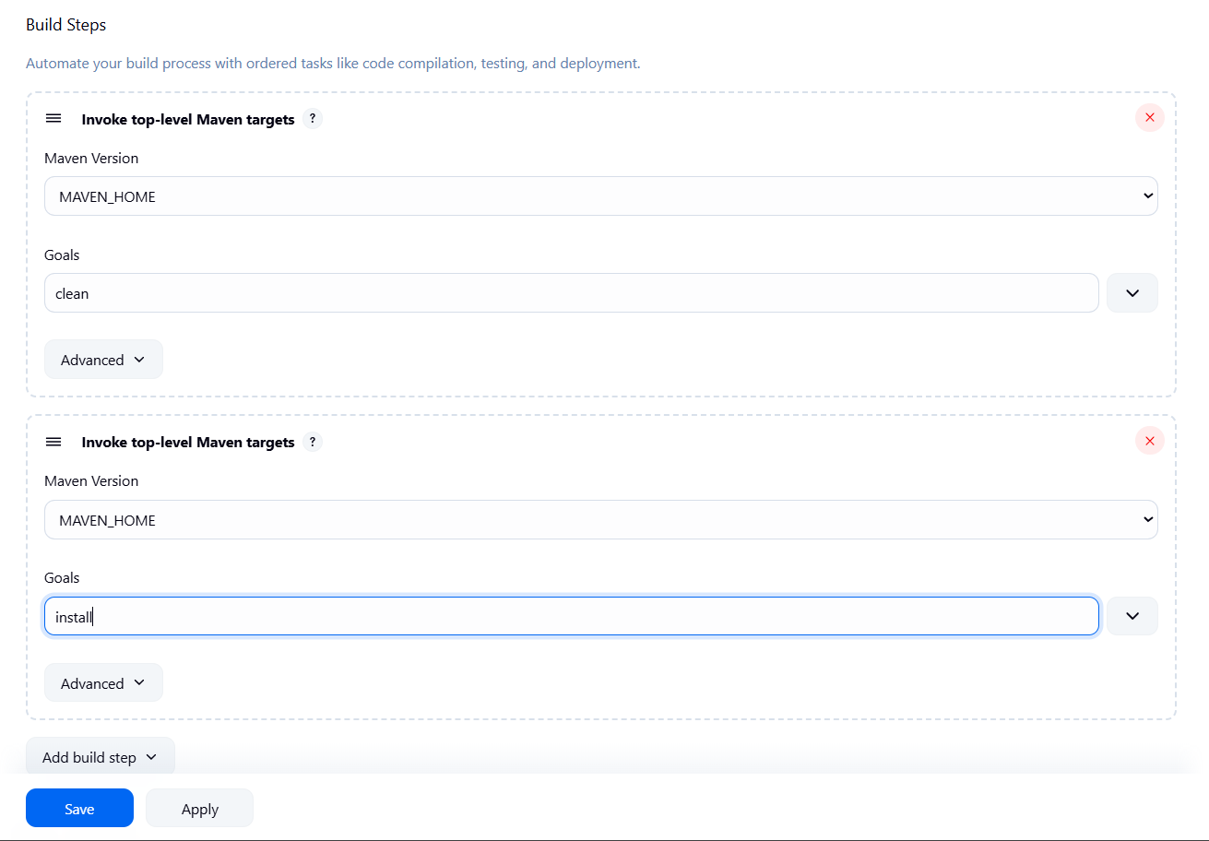
└── Post-build Actions:
├── Add Post Build Action -> "Archive the artifacts"
└── Files to archive: **/*
├── Add Post Build Action -> "Build other projects"
└── Projects to build: MavenWeb_Test
└── Trigger: Only if build is stable
└── Apply and Save
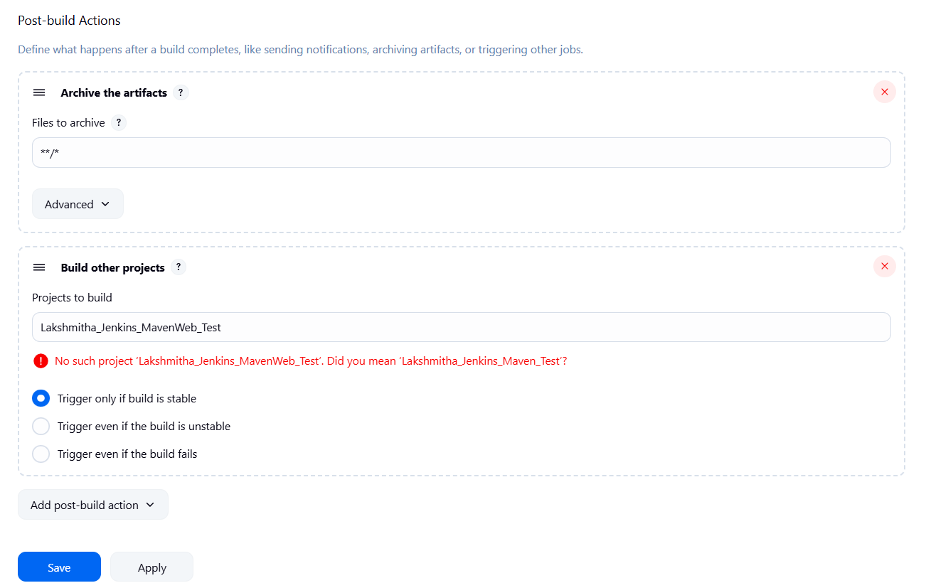

└── Step 3: Create Freestyle Project (e.g., MavenWeb_Test)
├── Enter project name (e.g., MavenWeb_Test)
├── Click "OK"
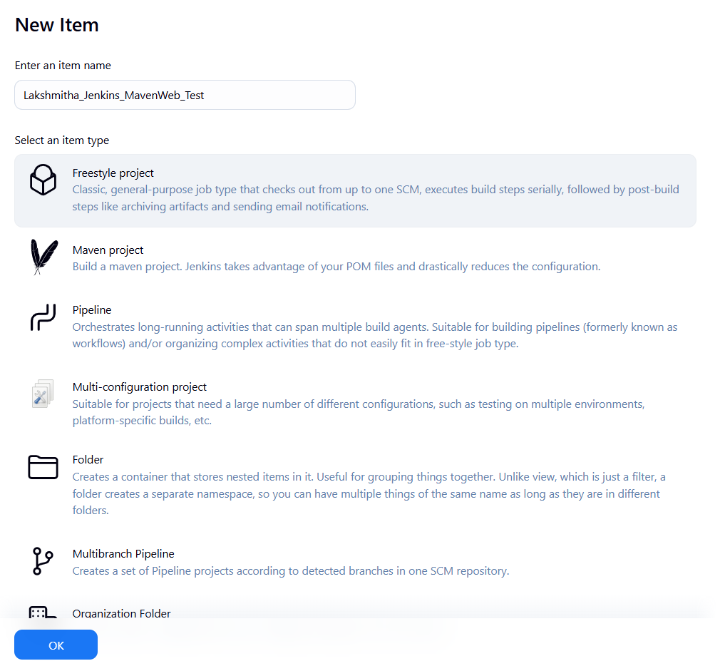
└── Configure the project:
├── Description: "Test demo"
├── Build Environment:
└── Check: "Delete the workspace before build starts"
├── Add Build Step -> "Copy artifacts from another project"
└── Project name: MavenWeb_Build
└── Build: Stable build only
└── Artifacts to copy: **/*
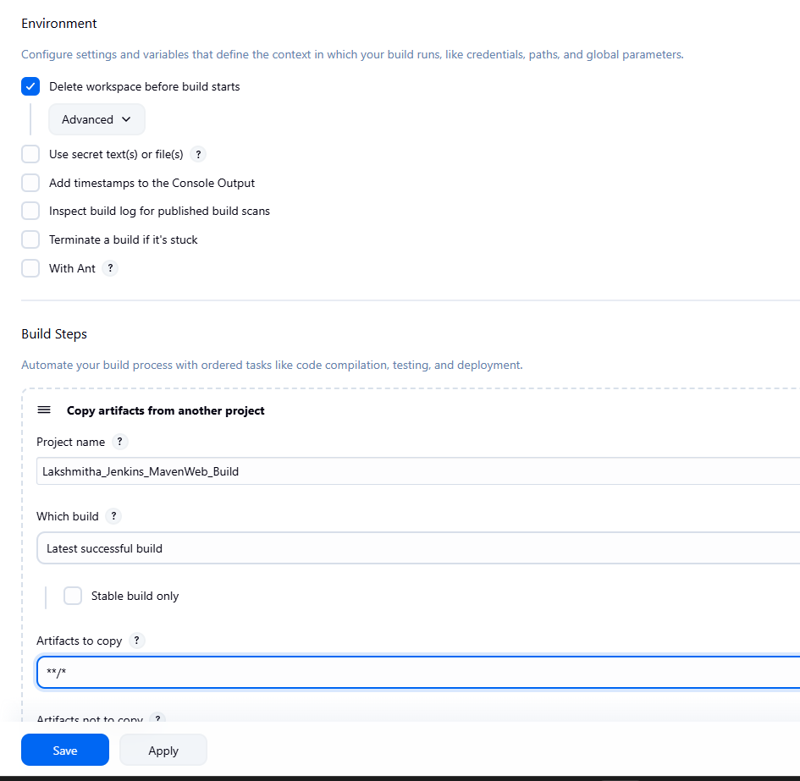
├── Add Build Step -> "Invoke top-level Maven targets"
└── Maven version: MAVEN_HOME
└── Goals: test
└── Post-build Actions:
├── Add Post Build Action -> "Archive the artifacts"
└── Files to archive: **/*
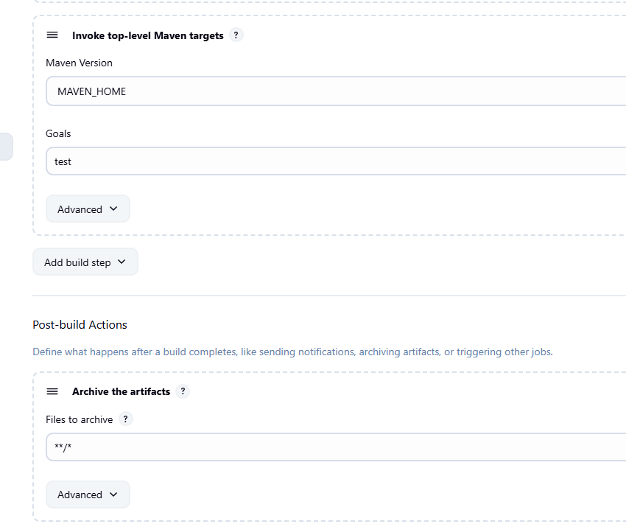
├── Add Post Build Action -> "Build other projects"
└── Projects to build: MavenWeb_Deploy
└── Apply and Save
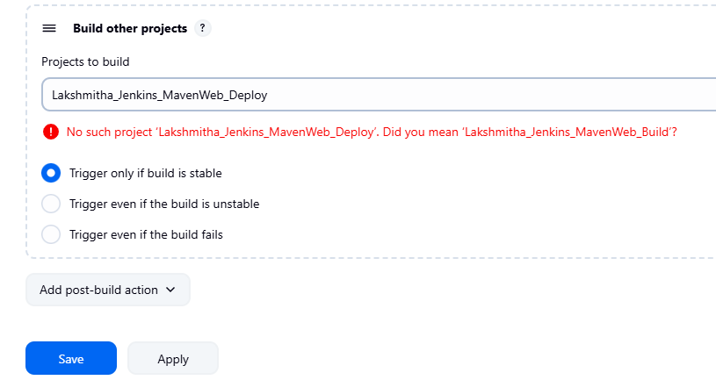
└── Step 4: Create Freestyle Project (e.g., MavenWeb_Deploy)
├── Enter project name (e.g., MavenWeb_Deploy)
├── Click "OK"
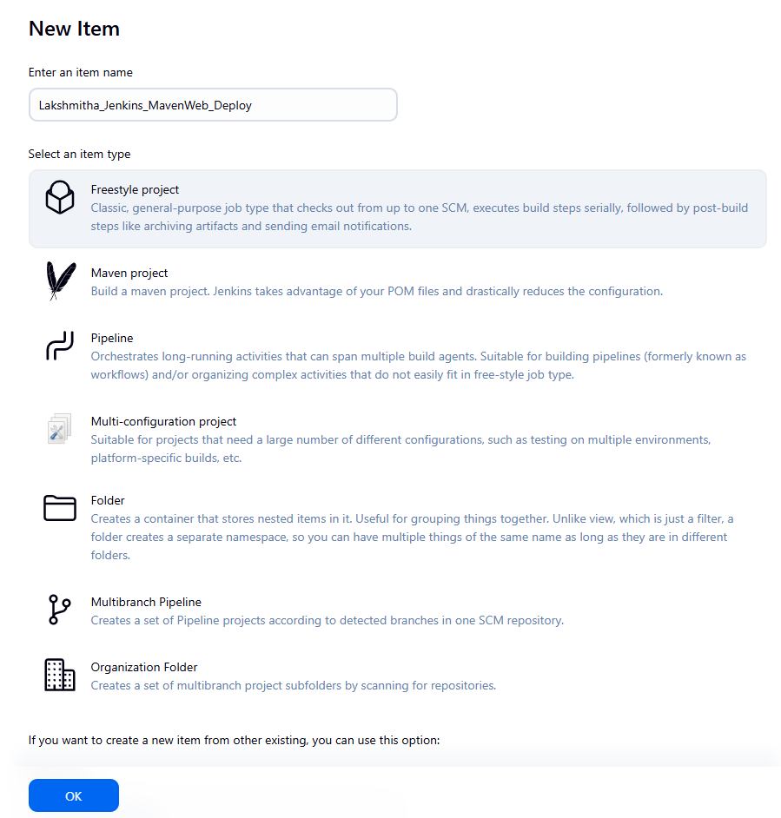
└── Configure the project:
├── Description: "Web Code Deployment"
├── Build Environment:
└── Check: "Delete the workspace before build starts"
├── Add Build Step -> "Copy artifacts from another project"
└── Project name: MavenWeb_Test
└── Build: Stable build only
└── Artifacts to copy: **/*
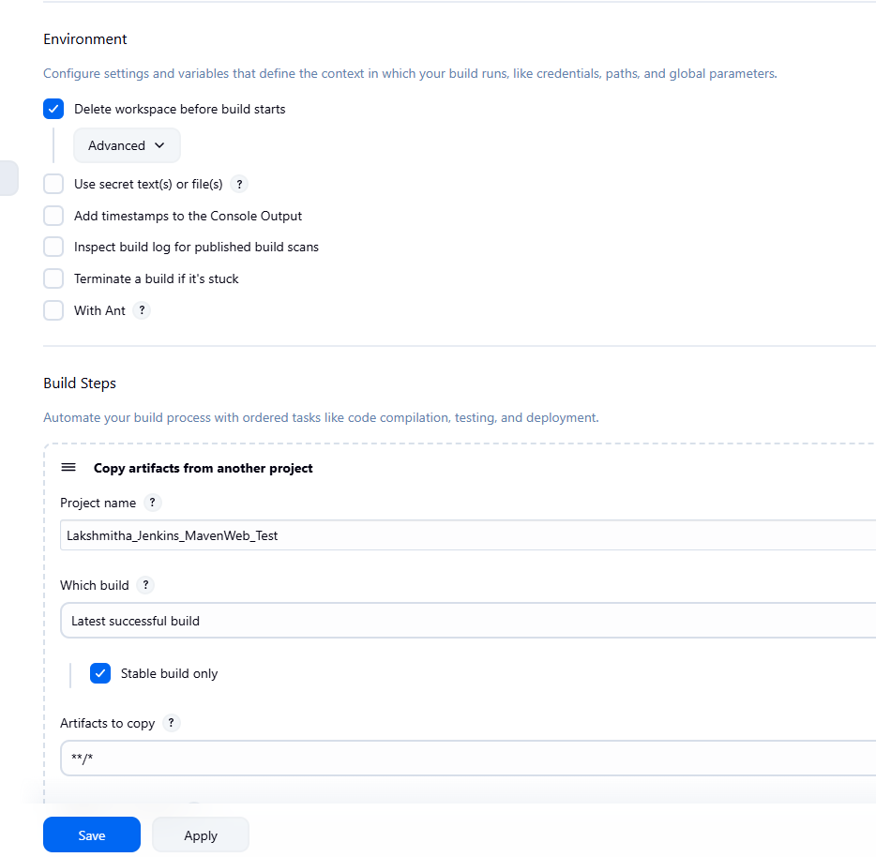
└── Post-build Actions:
├── Add Post Build Action -> "Deploy WAR/EAR to a container"
└── WAR/EAR File: **/*.war
└── Context path: Webpath
└── Add container -> Tomcat 9.x remote
└── Credentials: Username: admin, Password: 1234
── Tomcat URL: https://localhost:8085/
└── Apply and Save
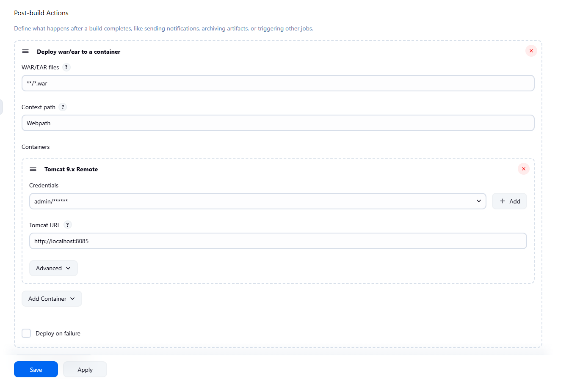

└── Step 5: Create Pipeline View for MavenWeb
├── Click "+" beside "All" on the dashboard
├── Enter name: MavenWeb_Pipeline
├── Select "Build pipeline view"
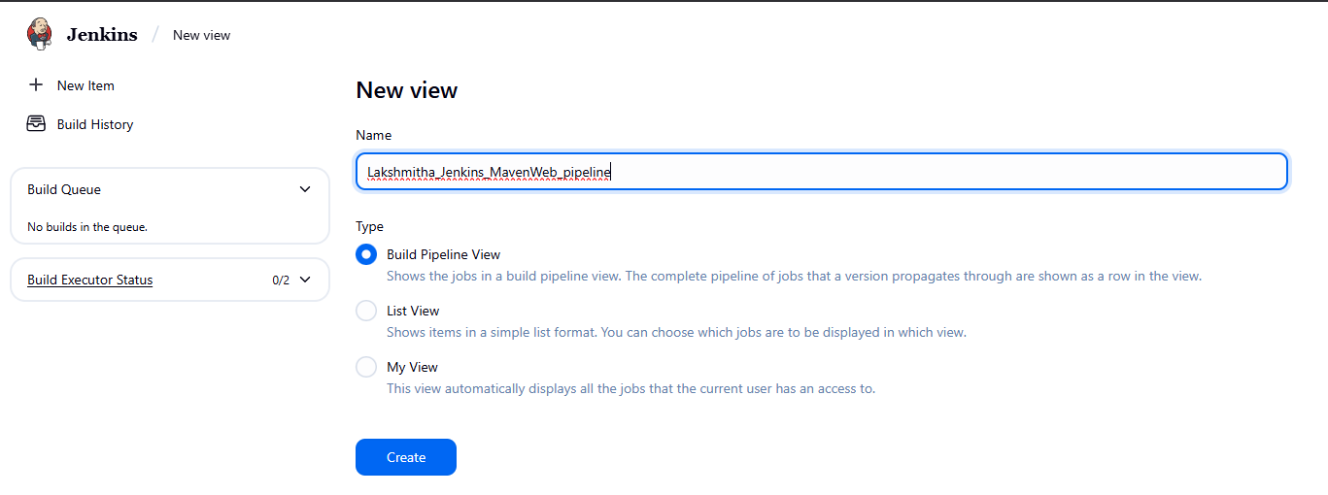

└── Pipeline Flow:
├── Layout: Based on upstream/downstream relationship
├── Initial job: MavenWeb_Build
└── Apply and Save
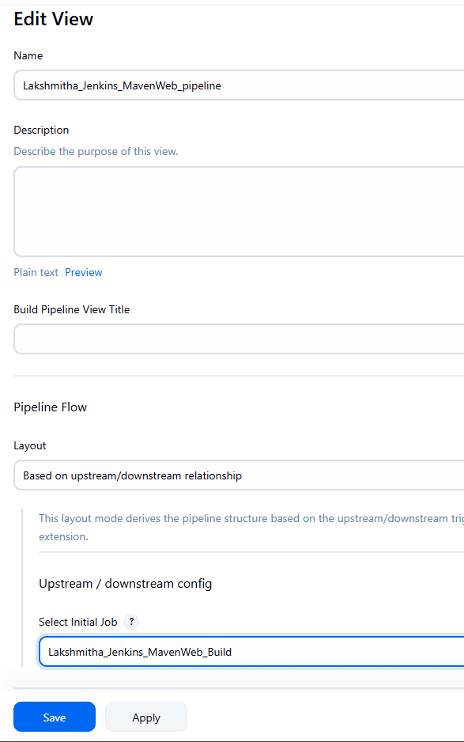

└── Step 6: Run the Pipeline and Check Output
├── Click on the trigger “RUN” to run the pipeline
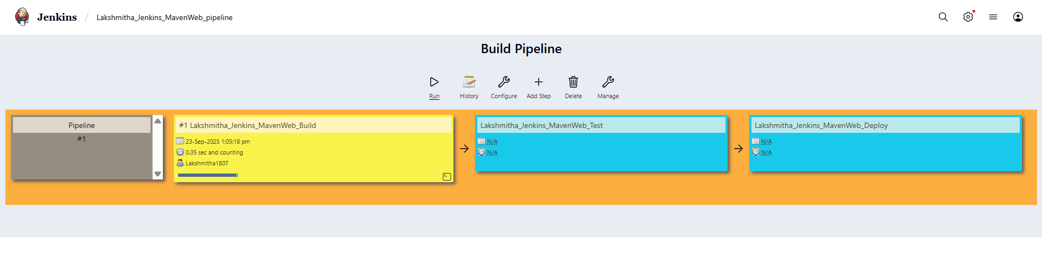
Note:
- After Click on Run -> click on the small black box to open the console to check if the build is success
- Now we see all the build has success if it appears in green color
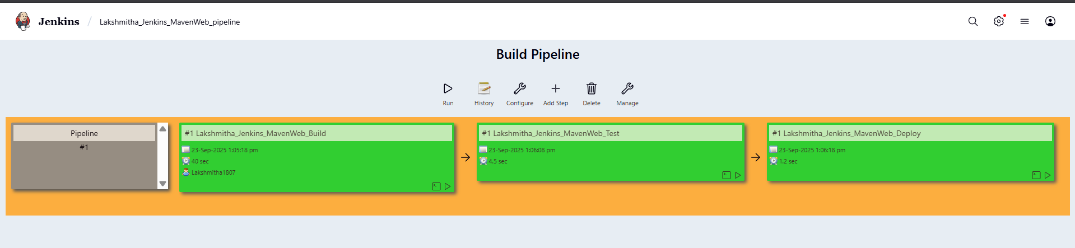o
├── Open Tomcat homepage in another tab
├── Click on the "/webpath" option under the manager app
Note:
- It ask for user credentials for login ,provide the credentials of tomcat.
- It provide the page with out project name which is highlighted.
- After clicking on our project we can see output.

- Questions on Jenkins
- What is Jenkins primarily used for?
Jenkins is primarily used for Continuous Integration (CI) and Continuous Delivery/Deployment (CD) to automate building, testing, and deploying applications.
- What is feature of Jenkins?
Extensibility through plugins (over 1,800 available).
Pipeline as code (using Jenkinsfile).
Distributed builds across multiple nodes.
Integration with version control systems.
- What is the default port on which Jenkins runs?
8080
- What can be integrated with Jenkins for version control?
Git, Github,BitBucket,SVN
- What is the purpose of Jenkins plugins?
Plugins extend Jenkins’ core functionality by adding new integrations, build steps, UI enhancements, SCM support, and pipeline features.
- Which type of Jenkins job is best suited for running one-off tasks or small scripts?
FreeStyle Job
- How can you manage sensitive information such as API keys in Jenkins?
Using the Credentials Plugin, which stores secrets securely and injects them into builds.
- What does the "blue ocean" feature in Jenkins refer to?
A modern, user-friendly UI for Jenkins pipelines with visualization of stages and steps.
- What does the "blue ocean" feature in Jenkins refer to?
A modern, user-friendly UI for Jenkins pipelines with visualization of stages and steps.
- Which Jenkins component allows for distributed builds across multiple machines?
Jenkins Master-Agent architecture (agents handle distributed builds).
- List at least five Jenkins plugins that you would consider important for a microservices-based application CI/CD pipeline. Briefly explain the purpose of each plugin.
Maven Integration Plugin – Automates building, testing, and packaging microservices using Maven.
Build Pipeline Plugin – Visualizes and manages multi-stage CI/CD workflows.
Pipeline Utility Steps Plugin – Provides extra steps for handling files, JSON, and YAML in pipelines.
Copy Artifacts Plugin – Shares build outputs between dependent Jenkins jobs.
Deploy to Container Plugin – Automates deployment of applications to servers like Tomcat/JBoss.
Git SCM / Blue Ocean Plugin – Integrates Git repos and offers a modern UI for pipeline visualization.
- Explain the steps you would take to install a plugin in Jenkins through the Jenkins UI. What considerations would you keep in mind regarding plugin compatibility and updates?
Go to Manage Jenkins → Manage Plugins.
Search in the Available tab.
Select plugin → click Install without restart (or with restart if required).
Considerations:
Ensure plugin version is compatible with Jenkins version.
Check for dependency requirements.
Avoid outdated or unmaintained plugins.

- Explain the steps you would take to install a plugin in Jenkins through the Jenkins UI. What considerations would you keep in mind regarding plugin compatibility and updates?
- After installing a plugin, explain how you would configure it within Jenkins. For example, if you installed the Git Plugin, what steps would you take to set it up for your pipeline?
• Go to Manage Jenkins → Global Tool Configuration.
• Add Git installation path.
• In your pipeline/job, configure Git repository URL and credentials.
• Test connection to ensure Jenkins can access the repo.
- Discuss common issues that might arise when using Jenkins plugins, such as dependency conflicts or version compatibility problems. How would you troubleshoot these issues?
Dependency conflicts – One plugin may require a different version of another.
Version incompatibility – Plugins may not support the installed Jenkins core.
Security vulnerabilities – Outdated plugins may have security issues.
Troubleshooting:
Check Jenkins logs for errors.
Review plugin documentation & compatibility matrix.
Upgrade/downgrade plugin versions carefully.
Use Jenkins Plugin Manager → Updates to patch issues.
If broken, uninstall plugin or roll back using a backup.

Conclusion: In this week student learnt automating Maven projects through Jenkins.

